GCSE - Flood management in the River Culm worksheet
- Describe three reasons why the River Culm is susceptible to flooding.
------------------------------------------------------------------------------------------------------------------------------------------------------------------------------------------------------------------------------------------------------------------------------------------------------------------------------------------------------------------------------------------------------------------
- Using the photo, describe how flooding can affect people, property, farmers and transport.
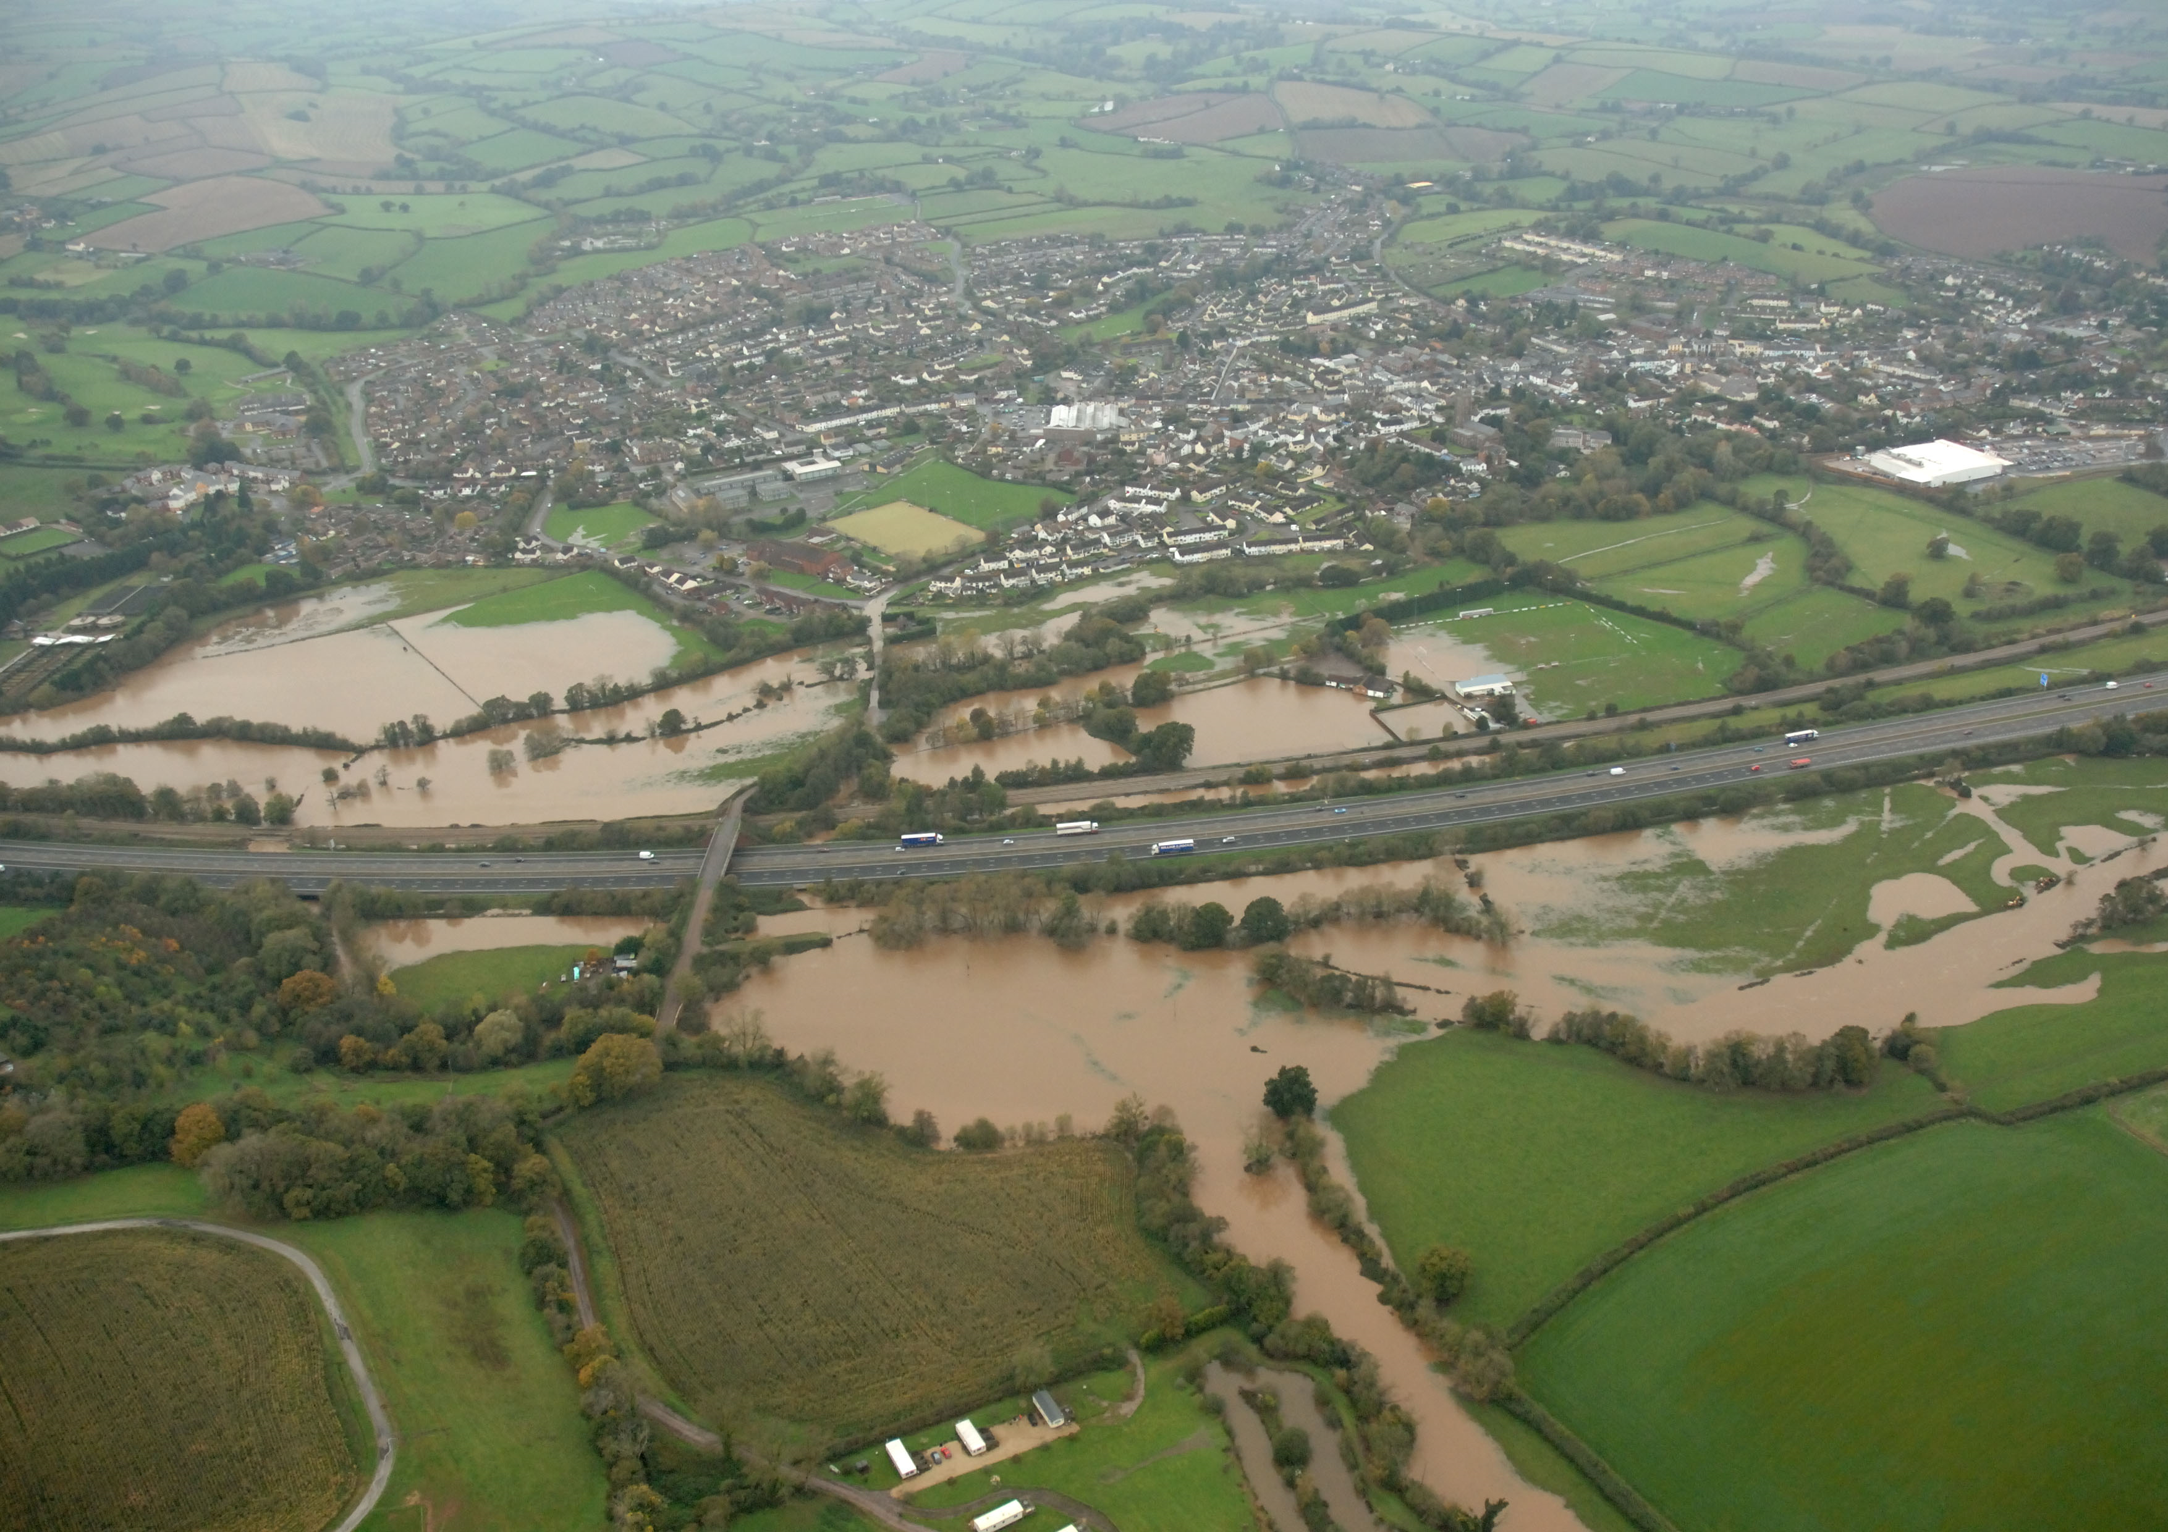

----------------------------------------------------------------------------------------------------------------------------------------------------------------------------------------------------------------------------------------------------------------------------------------------------------------------------------------------------------------------------------------------------------------------------------------------------------------------------------------------------------------------------------------------------------------------------------------------------------------------------------------------------------------------------------------------
--------------------------------------------------------------------------------------------------------------------------------------
- In some areas, hard engineering solutions are needed to protect housing, industry, bridges, roads and railways.

- What is meant by ‘hard engineering’?
----------------------------------------------------------------------------------------------------------------------------------------------------------------------------------------------------------------------------------------------------------------------------
- Describe what is happening in the photo below and suggest how it will reduce the risk of flooding.
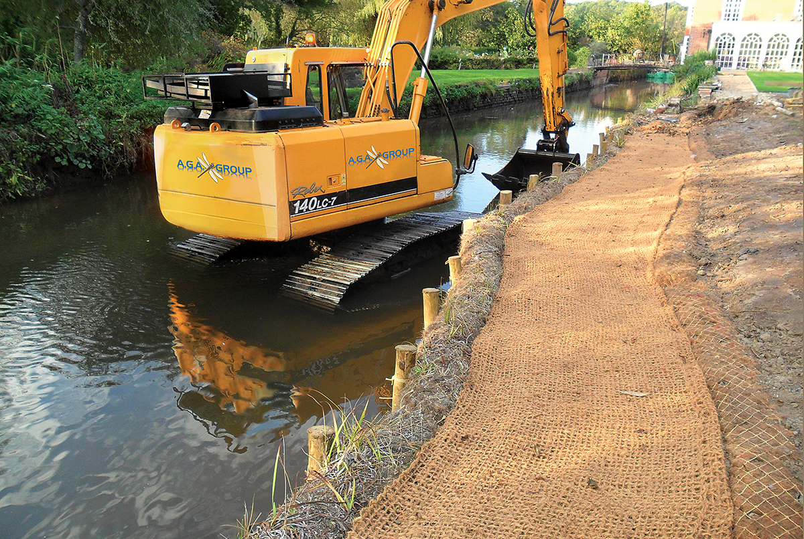
------------------------------------------------------------------------------------------------------------------------------------------------------------------------------------------------------------------------------------------------------------------------------------------------------------------------------------------------------------------------------------------------------------------------------------------------------------------------------------------------------------------------------------------------------------------------------------------------------------------------------------------------------------------------------------------------------------------------------------------------------------------------------------------------------------------------------------

- Explain one advantage and one disadvantage of hard engineering as a way of controlling river floods.
Advantage:
----------------------------------------------------------------------------------------------------------------------------------------------------------------------------------------------------------------------------------------------------------------------------
Disadvantage:
----------------------------------------------------------------------------------------------------------------------------------------------------------------------------------------------------------------------------------------------------------------------------
- On the river Culm, nature-based solutions (e.g. woodland management, river restoration and soil management) are being encouraged as a way of reducing the effects of river flooding on people and property. Using the photo, describe how woodland management can reduce the risk of flooding.
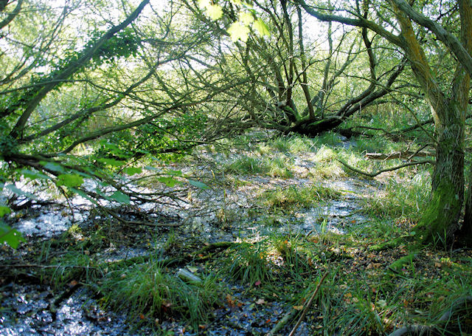

--------------------------------------------------------------------------------------------------------------------------------------------------------------------------------------------------------------------------------------------------------------------------------------------------------------------------------------------------------------------------------------------------------------------------------------------------------------------------------------------------------------------------------------------------------
- In the future, allowing beavers to live in the headwaters of the River Culm catchment may be another form of nature-based solutions to reduce flooding. Explain how beaver dams can help reduce flood peaks downstream.

--------------------------------------------------------------------------------------------------------------------------------------------------------------------------------------------------------------------------------------------------------------------------------------------------------------------------------------------------------------------------------------------------------------------------------------------------------------------------------------------------------------------------------------------------------
- The plan for Culm Garden Village includes the development of SuDS -sustainable drainage systems. Using the diagram below, outline three ways in which SuDS may reduce the urban flood risk.
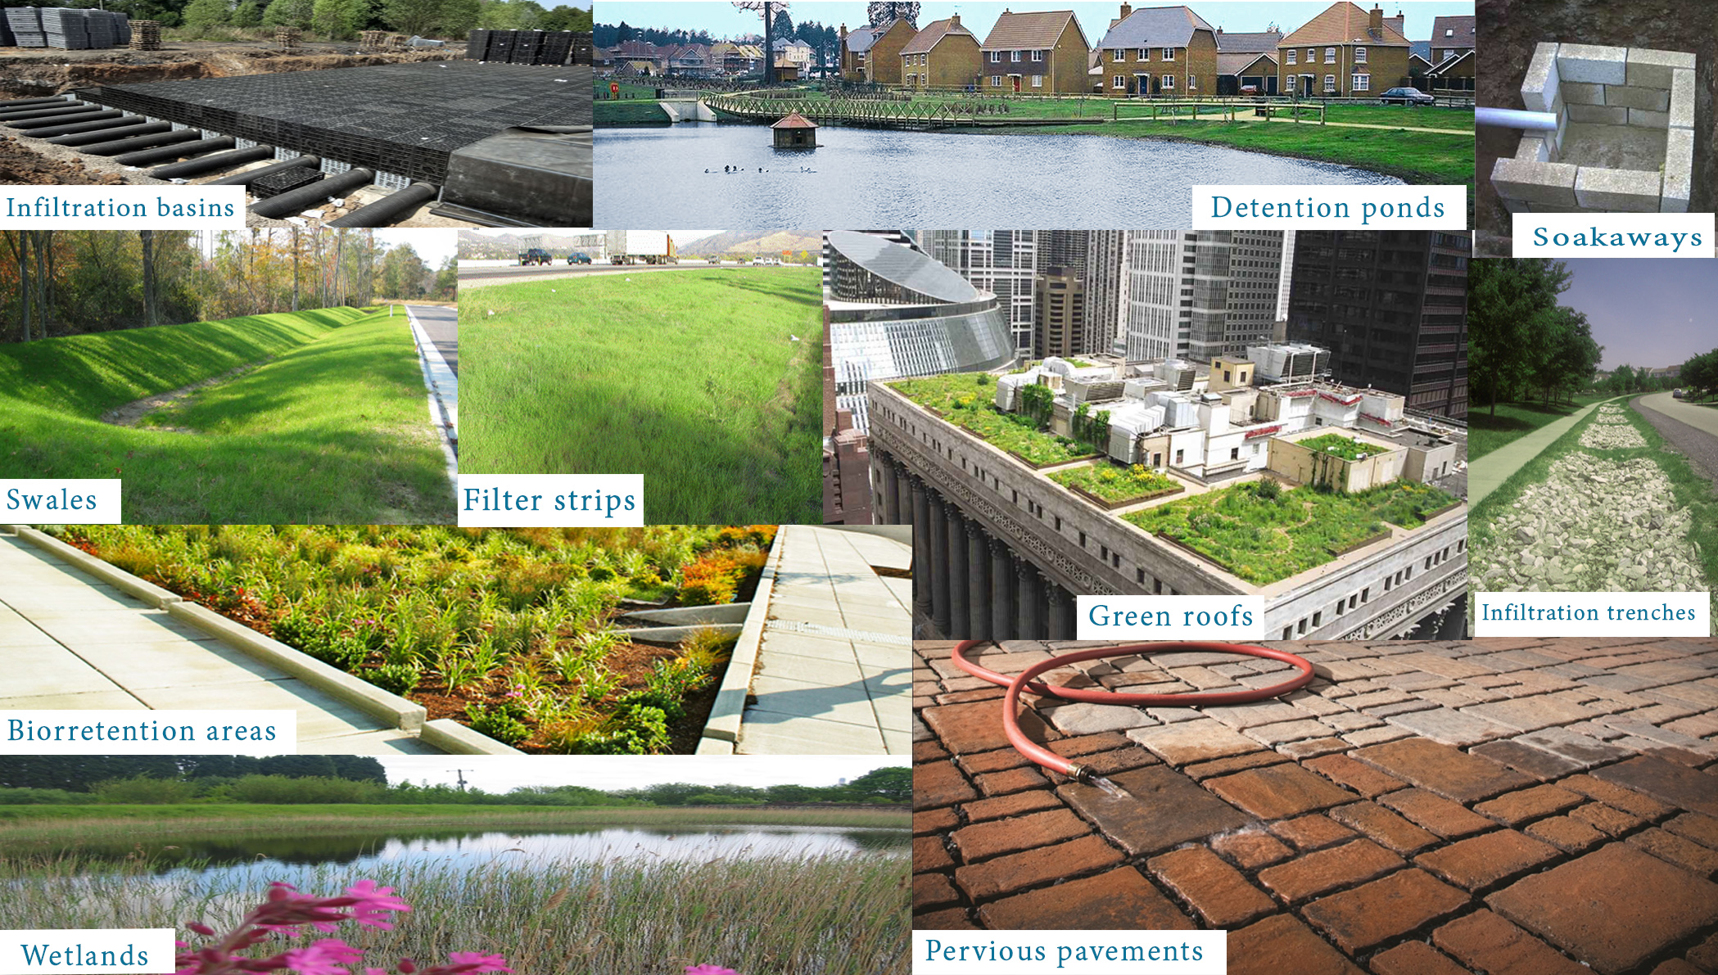

------------------------------------------------------------------------------------------------------------------------------------------------------------------------------------------------------------------------------------------------------------------------------------------------------------------------------------------------------------------------------------------------------------------------------------------------------------------------------------------------------------------------------------------------------------------------------------------------------------------------------------------------------------------------------------------------------------------------------------------------------------------------------------------------------------------------------------
- Explain how restoration of the River Culm at Silverton Mill has helped to reduce risk of flooding and encourage wildlife.





